 | Department of Computer Science  Faculty of Computing

Project Task 1
(Project Setup)

Programme | : | Bachelor of Computer Science (Data Engineering)
Subject Code | : | SECR1213
Subject Name | : | Network Communications
Session-Sem | : | 2024/2025-1

Prepared by | : |  | 1)Chau Ying Jia  2)Poh Lok Yee  3)Sabrina Heng Wei Qi  4)Woo Cheng Shuan | (A22CS0213)  (A23CS0262)  (A23CS0265)  (A23CS0283)
Section | : |  | 12
Group | : |  | 12.3 – 4Fabs
Lecturer | : |  | Mr. Firoz Bin Yusuf Patel Dawoodi

Table of Content
Brief Explanation for The Task 3
Floor plan for ground floor 4
Floor plan for first floor 5
Brief Explanation for The Layout 6
Enhanced Floorplan by using Packet Tracer 7
MEETING MINUTES #1 8
MEETING MINUTES #2 11
MEETING MINUTES #3 13

Brief Explanation for The Task

Task 1 which is project setup focuses on creating a team and establishing the foundation setup for a small network design project. This project is to accommodate the growth of the students over the next 20 years, as the computing field grows and moves forward into the future. We formed our group of four students, including Chau Ying Jia, Poh Lok Yee, Sabrina Heng Wei Qi and Woo Cheng Shuan. We selected 4Fabs as our group name. The team’s objective is to understand the case study and design a new 2-storey building. This building must house 4 labs which is 2 general purpose labs, 1 Cisco Network lab and 1 Embedded lab. Besides, it must also include 1 video conferencing room, 1 hybrid classroom and a student lounge. Additionally, our group members will document all group meetings in detailed minutes, outlining discussions, decisions and responsibilities.

Group members have to research and based on each room different purpose, design in detail including what equipment and the fair positioning of them in the rooms. The floorplan is also part of our task to design a building layout based on the required room with additional for the daily purposes of students and lecturer to meet the needs of daily users. This project focuses on planning and designing an infrastructure that supports the faculty's growth objectives and technological requirements, ensuring it remains both efficient and secure. The success and grade of the project will depend on the team's ability to collaborate effectively and produce a well-thought-out, high-quality design.

Floor plan for Ground Floor
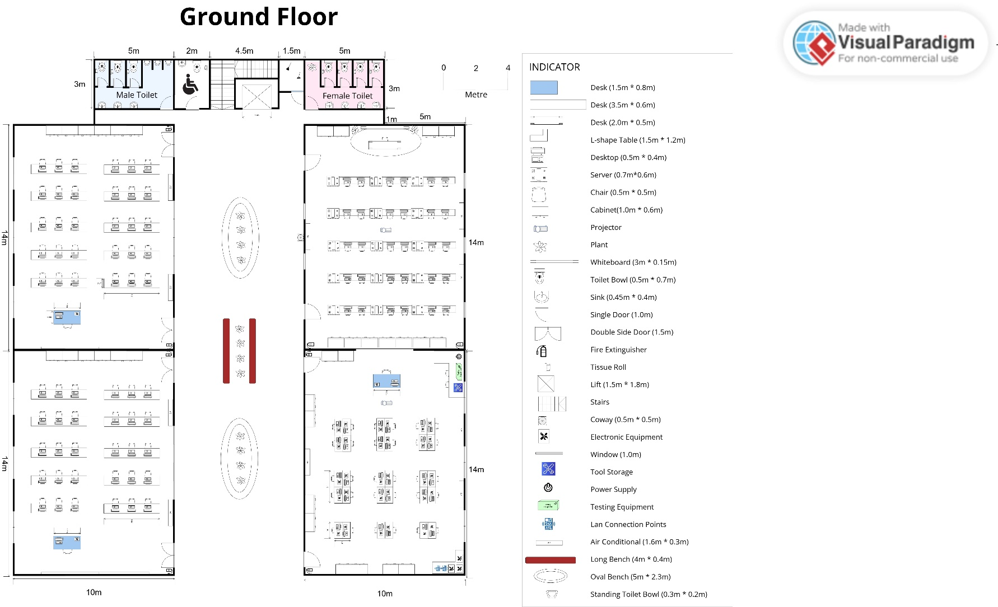

Floor plan for First Floor

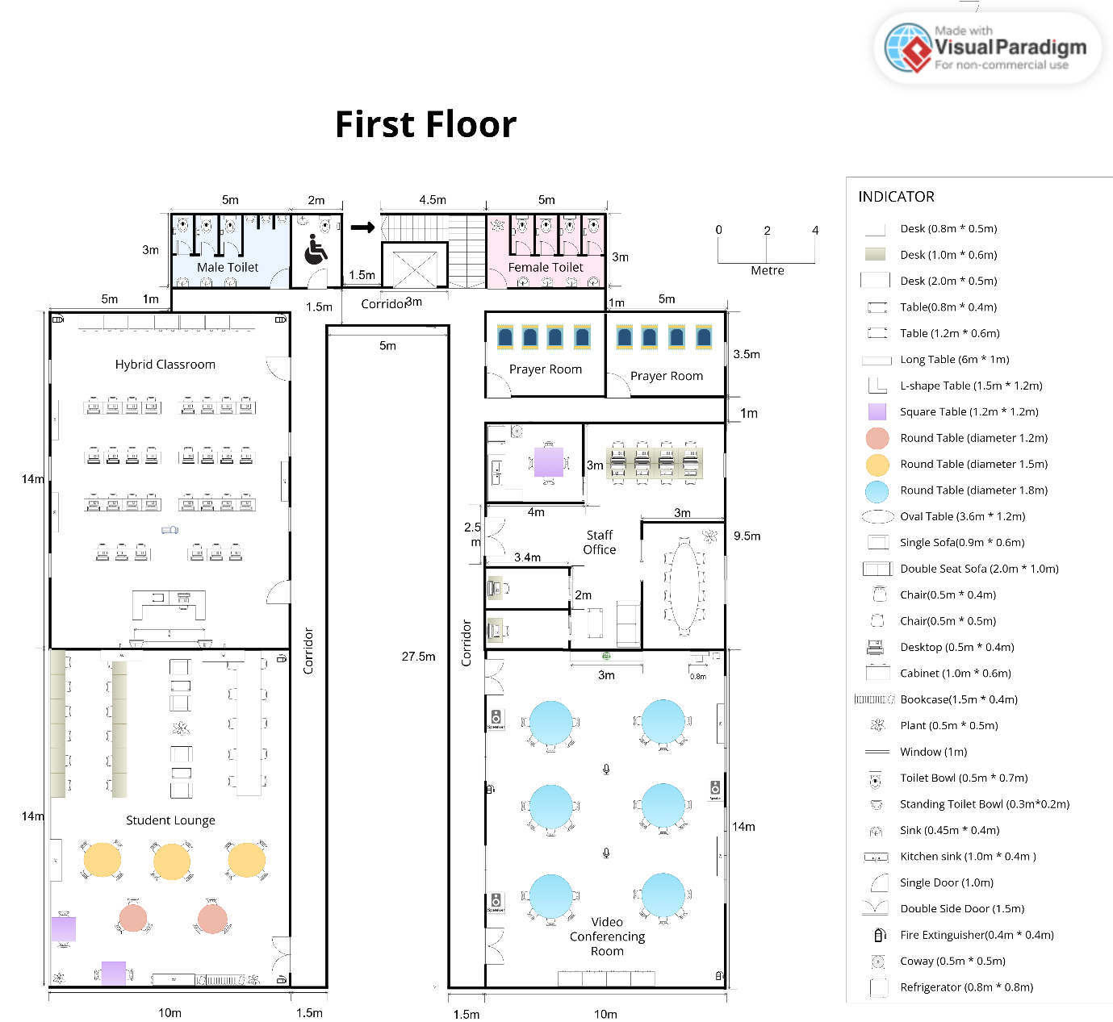

Brief Explanation for The Layout

We are establishing four laboratories on the ground floor which are two general laboratories, a Cisco Network Lab, and an Embedded Lab. The two general labs are positioned on the left side of the building, while the Cisco Network Lab and the Embedded Lab are located on the right side. Centrally situated is a lift, surrounded by stairs. At the back of the left wing, there is a male restroom, along with an accessible restroom next to the stairs. Conversely, the female restroom is located on the opposite side of the stairs. The center of the building features greenery and benches for students to utilize.

For the first floor, we have designated spaces for the Student Lounge, Staff Office, Hybrid Classroom, and Video Conferencing Room. The Student Lounge is strategically positioned on this level due to its quieter environment, minimizing people passing by and creating a more conducive atmosphere for students. As illustrated, the Student Lounge and Hybrid Classroom are located on the left side, while the Staff Office and Video Conferencing Room are situated on the right side of the building. Additionally, we have allocated two prayer rooms beside the staff room for the male and female Muslims separately. Finally, the design and placement of both the female and male restrooms mirror those on the ground floor.

Enhanced Floorplan by using Packet Tracer
Ground floor
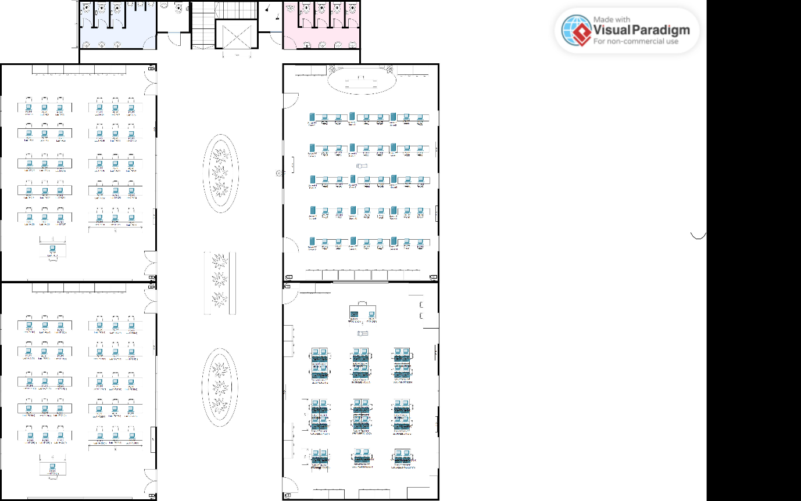
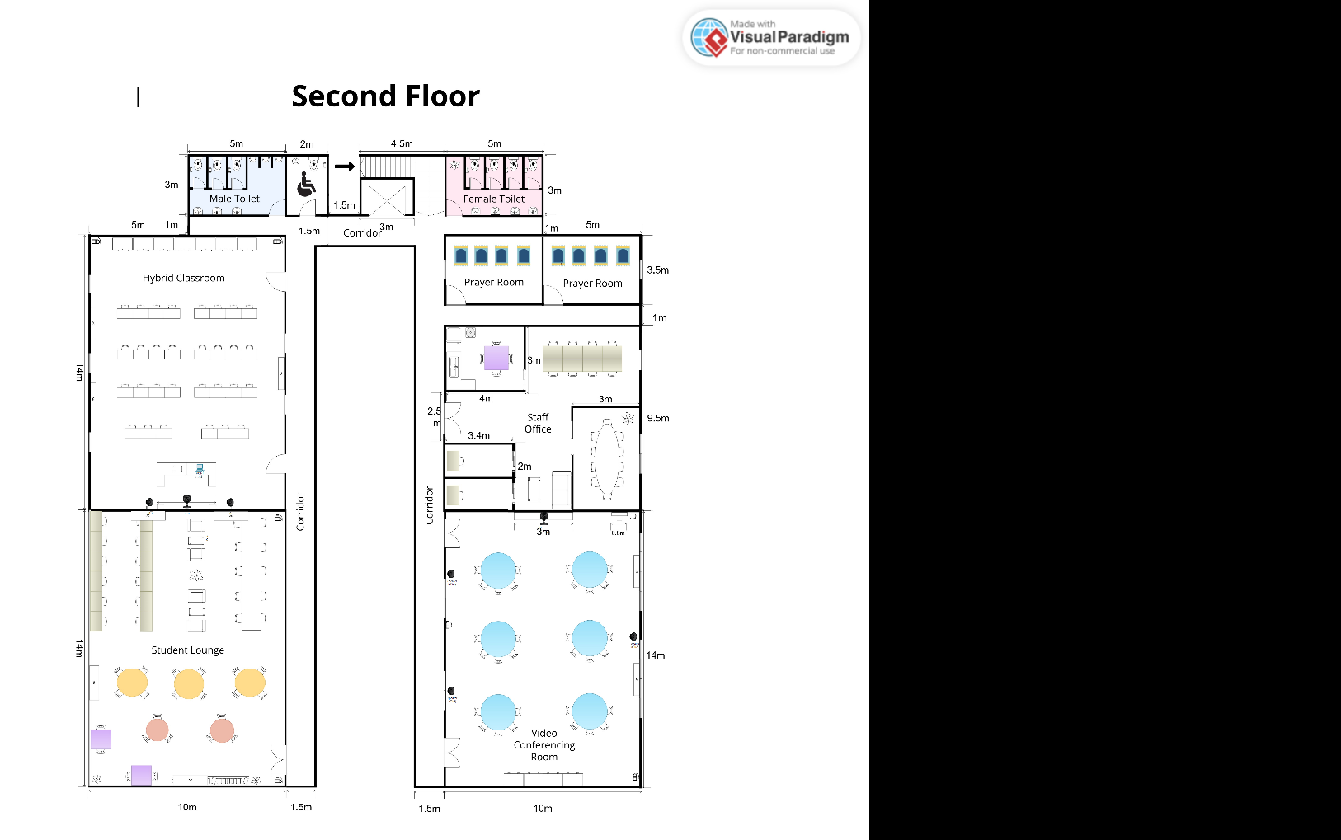

MEETING MINUTES #1
DATE/TIME |  | 4 Nov 2024 3pm
LOCATION |  | Arked Angkasa
AGENDA |  | - Discuss about all the task from task 1  - Tool for designing floor plan  - Floor plan arrangement  - Task distribution for each person
Meeting MC |  | Poh Lok Yee
ATTENDANCE
NAME |  | TIME | REASON FOR ABSENCE
Poh Lok Yee |  | 1500 | -
Woo Cheng Shuan |  | 1500 | -
Chau Ying Jia |  | 1500 | -
Sabrina Heng Wei Qi |  | 1520 | -
MINUTES
NO. | ITEM DISCUSSED | IDEAS/SUGGESTIONS AND PERSON GIVING IT | PERSON IN CHARGE
1 | Suggest group name | All members suggested 4fabs as group name | All members
2 | Shirt discussion on Task 1 | All members read and understand the task given | All members
3 | Software to use | Ying Jia suggested to use visual paradigm to draw floor plan | Ying Jia
4 | Building design | Ying Jia and Cheng Shuan suggested building design in rectangle shape  Lok Yee suggested building design in octagon shape | Ying Jia and Cheng Shuan
5 | Decision on building design | Sabrina, Ying Jia and Cheng Shuan drew the draft for rectangle building design  Lok Yee drew the draft for octagon building design  All members discuss on the advantages and disadvantages between the designs and make final decision on building design | All members
6 | Floor plan design | All members discuss floor plan design  Lok Yee suggested adding lift and accessible toilet for disability friendly  Cheng Shuan suggested all 4 labs at the lower ground  Sabrina suggested the size for Video conferencing room and hybrid classroom  Ying Jia drew the draft of floor plan design | All members
7 | Task distribution | Lok Yee distributes the tasks for each member by using spin tools  Outcomes:  Lok Yee is responsible for designing the student lounge and first floor, Ying Jia is responsible for designing the second floor and Embedded lab, Sabrina is responsible for designing Cisco Network lab and hybrid classroom while Cheng Shuan is responsible for designing the general lab and Video Conferencing room | Lok Yee
8 | Next Meeting | 8 November – All given tasks should be 90% completed | All members
9 | Meeting ended | 1715 | All members

MEETING MINUTES #2
DATE/TIME |  | 8 Nov 2024 2pm
LOCATION |  | KTDI MA7
AGENDA |  | - Finalize the floor plan  - Learn packet tracer
Meeting MC |  | Chau Ying Jia
ATTENDANCE
NAME |  | TIME | REASON FOR ABSENCE
Poh Lok Yee |  | 1400 | -
Woo Cheng Shuan |  | 1400 | -
Chau Ying Jia |  | 1400 | -
Sabrina Heng Wei Qi |  | 1400 | -
MINUTES
NO. | ITEM DISCUSSED | IDEAS/SUGGESTIONS AND PERSON GIVING IT | PERSON IN CHARGE
1 | Sharing session on current progress | All members shared own progresses | All members
2 | Comment and give suggestion for enhancement | Lok Yee reminded all labs must have 30 workstations  Cheng Shuan suggested all the same elements using same scale  Sabrina suggested the size of stairs and lift  Ying Jia suggested both floor toilets using same design | All members
3 | Design and edit each room and floor | All members edit the rooms following the suggestion and reminder from other group members | All members
4 | Combination of each lab and room on both floors and finalize the floor plan design | All members put each of their designs inside the ground floor and first floor and finalize the design | All members
5 | Next Meeting | 14 November – All members should download and learn how to use packet tracer | All members
6 | Meeting Ended | 1800 | All members

MEETING MINUTES #3
DATE/TIME |  | 14 Nov 2024 3pm
LOCATION |  | KTDI MA7
AGENDA |  | - Use Packet Tracer to enhance the floor plan  - Finalize the floor plan
Meeting MC |  | Sabrina Heng Wei Qi
ATTENDANCE
NAME |  | TIME | REASON FOR ABSENCE
Poh Lok Yee |  | 1500 | -
Woo Cheng Shuan |  | 1500 | -
Chau Ying Jia |  | 1500 | -
Sabrina Heng Wei Qi |  | 1500 | -
MINUTES
NO. | ITEM DISCUSSED | IDEAS/SUGGESTIONS AND PERSON GIVING IT | PERSON IN CHARGE
1 | Discuss function packet tracer | All members shared their own understanding on packet tracer | All members
2 | Use Packet Tracer to enhance the floor plan design | Each member use Packet Tracer to design their assigned room. | All members
3 | Finalize the floor plan | Finalize the floor plan | All members
4 | Meeting Ended | 1845 | All members

